**Assignment 2**

Develop website for any company which shows companies homepage,their introduction block,their offerings in sidebars,different menues like homepage,projects,contact details,Jobs,etc,use specifis shapes,colors,alignments,2d transfrm techniques,etc for developing the website pages.

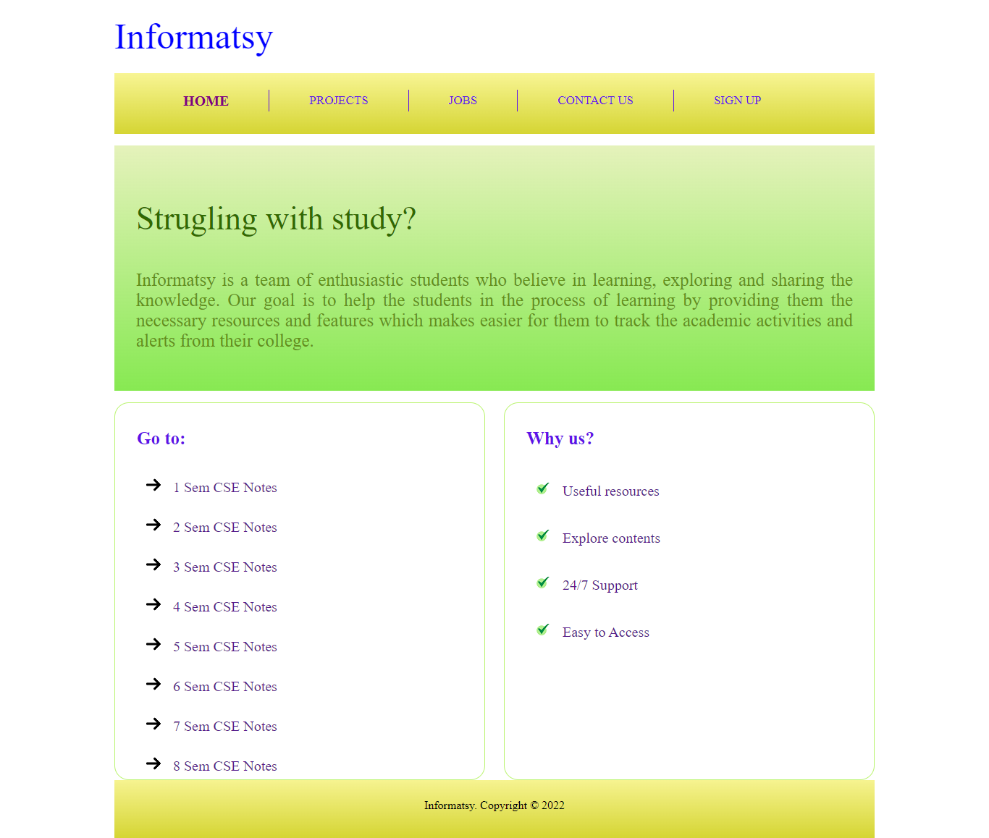

#Index.html

<!DOCTYPE html>

<html lang="en">

<head>

    <meta charset="UTF-8">

    <meta http-equiv="X-UA-Compatible" content="IE=edge">

    <meta name="viewport" content="width=device-width, initial-scale=1.0">

    <link rel="stylesheet" href="style.css">

    <title>Informatsy</title>

</head>

<body>

    <div id="container">

        <div id="header">

            <div id="brand">

                <h1><a href="#">Informatsy</a></h1>

            </div>

        </div>

        <div id="menu">

            <ul>

                <li>

                    <a href="#" class="active">Home</a>

                </li>

                <li>

                    <a href="#">Projects</a>

                </li>

                <li>

                    <a href="#">Jobs</a>

                </li>

                <li>

                    <a href="#">Contact Us</a>

                </li>

                <li>

                    <a href="#">Sign Up</a>

                </li>

            </ul>

        </div>

        <div id="introduction">

            <h3>Strugling with study?</h3>

            <p>

                Informatsy is a team of enthusiastic students who believe in learning, exploring and sharing the

                knowledge.

                Our goal is to help the students in the process of learning by providing them the necessary resources

                and features which makes easier for them to track the academic activities and alerts from their college.

            </p>

        </div>

        <div id="leftsidebar" class="sidebar">

            <h3>Go to:</h3>

            <ul>

                <li><a href="#">1 Sem CSE Notes</a></li>

                <li><a href="#">2 Sem CSE Notes</a></li>

                <li><a href="#">3 Sem CSE Notes</a></li>

                <li><a href="#">4 Sem CSE Notes</a></li>

                <li><a href="#">5 Sem CSE Notes</a></li>

                <li><a href="#">6 Sem CSE Notes</a></li>

                <li><a href="#">7 Sem CSE Notes</a></li>

                <li><a href="#">8 Sem CSE Notes</a></li>

            </ul>

        </div>

        <div id="rightsidebar" class="sidebar">

            <h3>Why us?</h3>

            <ul>

                <li><a href="#">Useful resources</a></li>

                <li><a href="#">Explore contents</a></li>

                <li><a href="#">24/7 Support</a></li>

                <li><a href="#">Easy to Access</a></li>

            </ul>

        </div>

        <div id="clear">

            <div id="footer">

                <div align="center">

                    <p>

                        Informatsy. Copyright &copy; 2022

                    </p>

                </div>

            </div>

        </div>

    </div>

</body>

</html>

#style.css

#container {

  width: 1050px;

  /* border: 1px solid grey; */

  height: 100px;

  margin: 0 auto;

}

h1 a {

  font-size: 50px;

  font-weight: 100;

  color: blue;

  text-decoration: none;

}

#menu {

  height: 70px;

  background: linear-gradient(#f8f594, #d5d533);

  padding: 7px 0;

}

ul {

  list-style: none;

}

#menu ul li {

  float: left;

  padding: 0 55px;

  height: 30px;

  border-right: 1px solid #5d12e7;

}

#menu ul li:last-child {

  border-right: none;

}

#menu ul li a {

  text-decoration: none;

  text-transform: uppercase;

  font-size: 17px;

  color: #5d12e7;

  line-height: 30px;

  -webkit-transition: font-size 0.3s ease;

  -moz-transition: font-size 0.3s ease;

  -o-transition: font-size 0.3s ease;

  transition: font-size 0.3s ease;

}

#menu ul li a:hover,

#menu ul li a.active {

  font-size: 20px;

  font-weight: bold;

  color: purple;

}

#introduction {

  background: linear-gradient(#e5f2bb, #87e952);

  padding: 30px;

  margin: 16px 0;

}

#introduction h3 {

  font-size: 45px;

  color: #316901;

  font-weight: normal;

}

#introduction p {

  font-size: 25px;

  color: #628f19;

  text-align: justify;

}

.sidebar {

  height: 500px;

  width: 450px;

  border: 1px solid #baf46f;

  border-radius: 20px;

  padding: 10px 30px;

}

.sidebar h3 {

  color: #b314db;

  font-size: 25px;

  color: #5d12e7;

}

.sidebar ul li a {

  text-decoration: none;

  font-size: 20px;

  -webkit-transition: font-size 0.3s ease;

  -moz-transition: font-size 0.3s ease;

  -o-transition: font-size 0.3s ease;

  transition: font-size 0.3s ease;

}

.sidebar ul li a:hover,

.sidebar ul li a.active {

  text-decoration: none;

  font-size: 23px;

  font-weight: bold;

  color: #b314db;

}

#leftsidebar {

  float: left;

}

#leftsidebar ul li {

  padding: 15px 0;

  padding-left: 10px;

  list-style-image: url(images/right-arrow.png);

}

#rightsidebar {

  float: right;

}

#rightsidebar ul li {

  padding: 20px 0;

  padding-left: 10px;

  list-style-image: url(images/check-mark.png);

}

#clear {

  clear: both;

}

#footer {

  height: 60px;

  background: linear-gradient(#f6f390, #d5d533);

  padding: 10px 30px;

  margin-top: 15px;

}